Application Note

|  |  |
| --- | --- |
| Product | 3D Printer 1800 |
| A/N # |  |
| Subject | Projection mapping on massivit 3d prints using Madmapper |
| No. Pages | 22 |
| Refer to T/N # |  |
| Written by | Monty Alon, Shahar Barnett, Ido De La Vega |
| Approved by |  |
| Edited by |  |
| Date | 24.9.2017 |

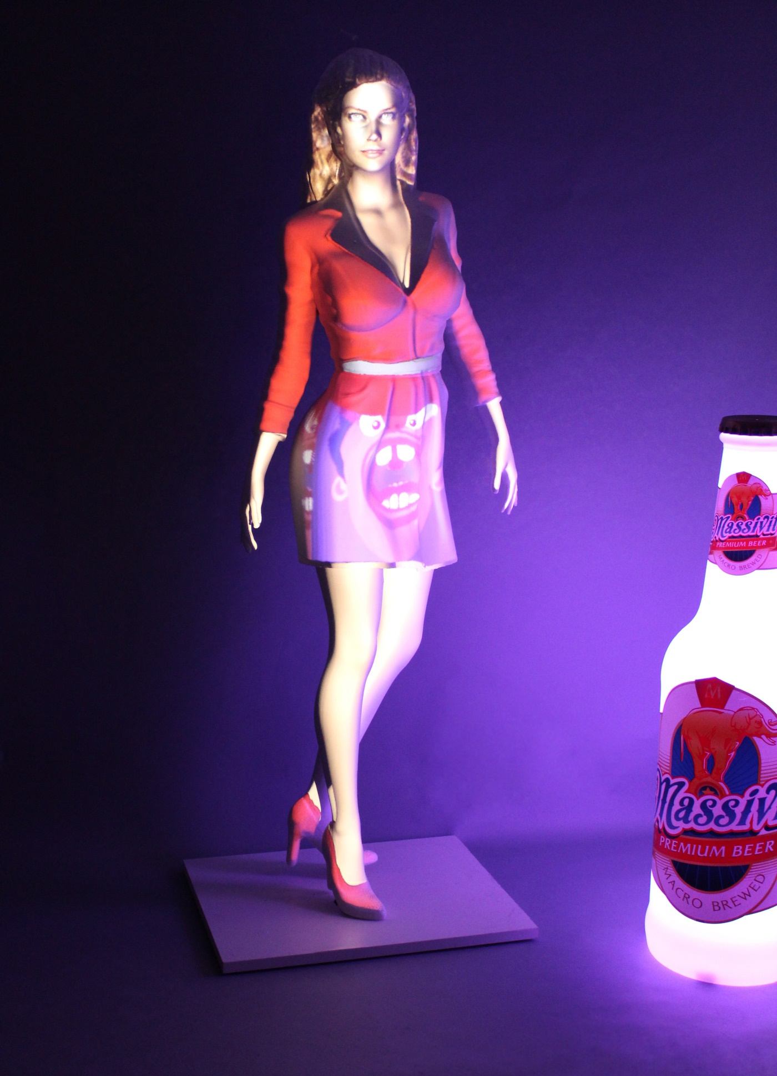

**1. Intro**

**2. Creation of the design**

Step 1 - Create a low-polygon-count version of the 3D Model

Step 2 - Using UV maps as a positioning guide

Step 3 - Editing the video

**3. installation**

Step 4 - Importing files into Madmapper

Step 5 - Creating a projection

Step 6 - Setting up the projection, prior to calibration

Step 7- Projection Mapping Calibration

Step 8 - Applying the video texture & adding effects

**4. Summary**

1. **Intro**

Projection mapping can be a great solution for adding texture, color and motion to your 3d displays. The advantage of printing in 3D for this purpose lies in the fact that UV maps are created from the original 3D file. When the Massivit 3D print is done, the projection mapping process is ready to go in a matter of a few simple steps.

The combination of Massivit 3D printers and Madmapper software offers a simple solution for creating complex eye popping displays with endless possibilities.

Video mapping is an innovative method of projecting a video movie on a 3D object with a great deal of precision. The method uses the 3D information used for printing to project an image onto that printed shape. The difficulty that is associated with Video Mapping arises when trying to perfectly align a 2D movie on a 3D object. This problem is aggravated further when the 3D object is more complex, where it may be almost impossible to have any alignment take place.

To address this issue, a 3D object that was generated and printed digitally is perfect, , since you have it’s digital information, for calculating the inherent distortion and achieve perfect alignment between the video and the 3D print.

This guide will take you step by step, for making a complete workflow to create your own video mapping.

Software and hardware required:

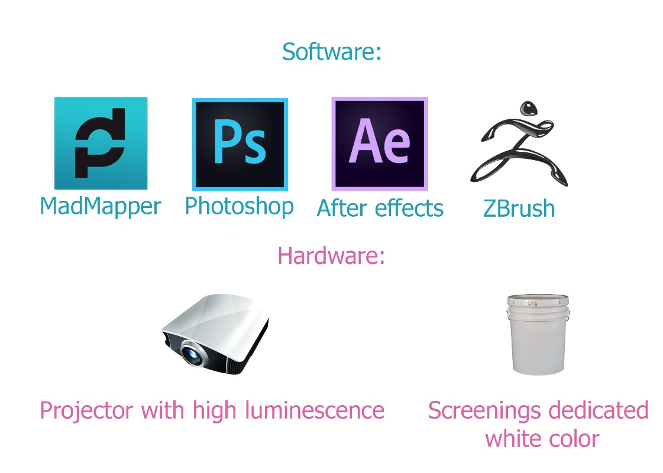

Basic knowledge in video editing is also required.

**2. Creation of the design**

**Step 1:** Create a low-polygon-count version of the 3D Model

For UV mapping extraction, we need to create a new version of the model.

This version needs to be the same model that was printed, but with a low polygon count. Also if the model was split for printing in several parts, it is now important to merge it and extract the UV-map from one model only.

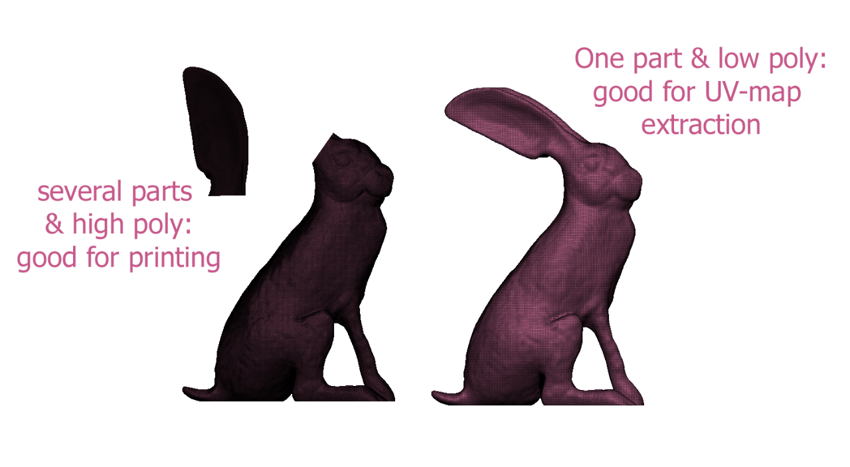

If we want to display some different videos, on different regions in the model, it is best to create UV islands.

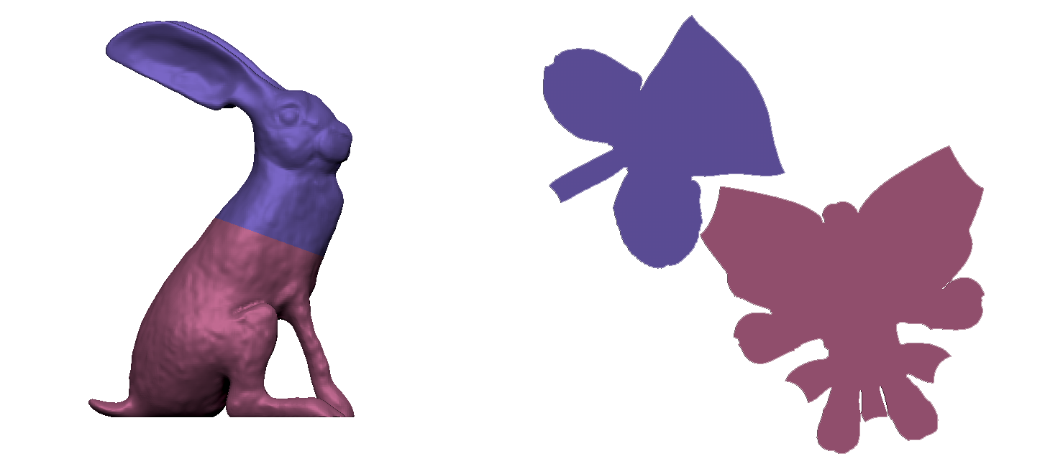

In Zbrush UV island can be created by using polygongrops on the model & marking “polygongrops” wail we are doing unwrap

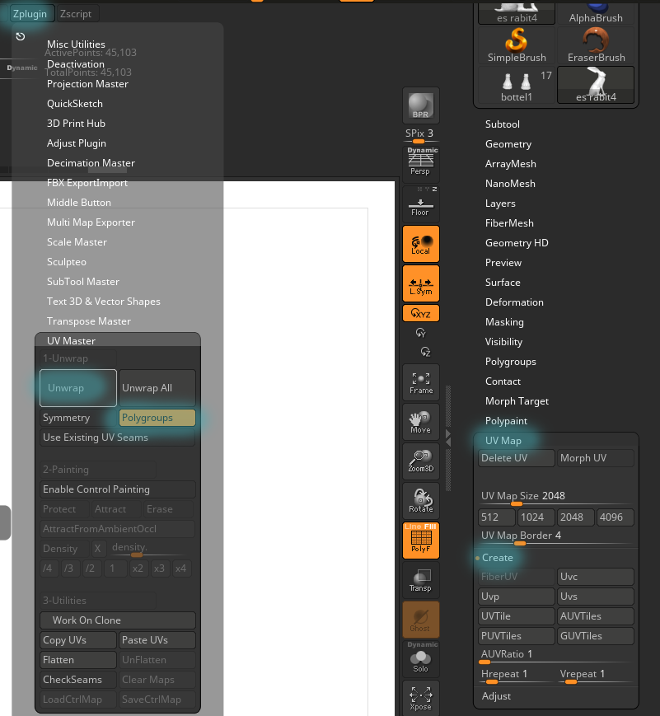

A 5 minutes video tutorial, on UV map in Zbrush, can be seen in the official site: http://pixologic.com/zclassroom/lesson/polygongroups-uv-master

**Step 2:** Using UV maps as a positioning guide

First create a UV map for the model. As discussed, for multiple texture projections, be sure to create multiple UV islands.

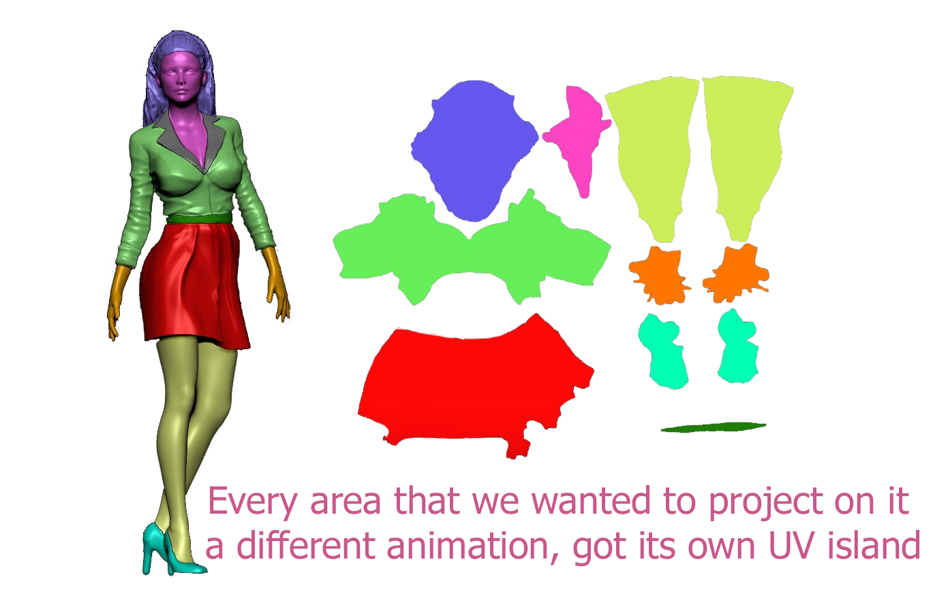

After creating the UV map, it is now needed to export it into Photoshop. This is done by creating a “Texture map” out of our existing uv map.

Go to Texture map – Create – New from Polygonpaint.

After that press “clone Txtr”

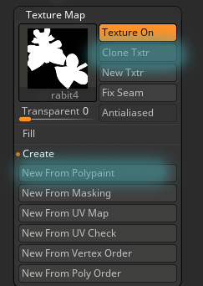

Once we press “clone Txtr” the map will go to the texture pallet on the right side of the screen. From this menu we can now export it in to Photoshop as a PSD file

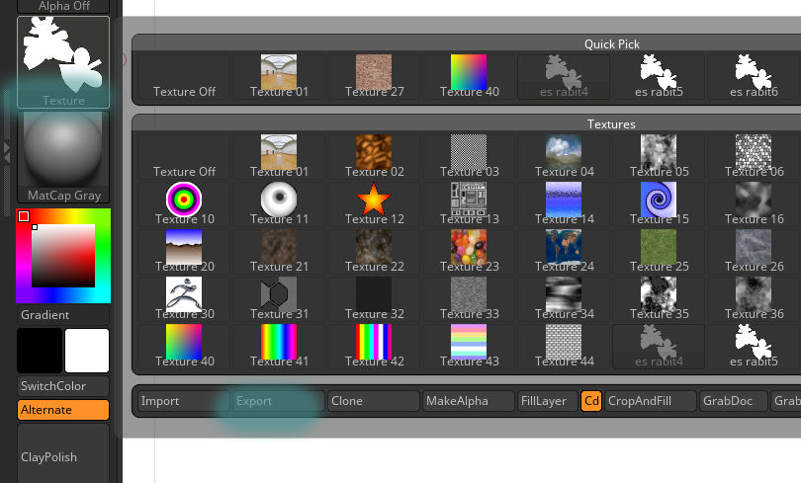

**Quick tip**: Save all your files in one folder (3D model, Video files & the Madmapper project.

Next, create a mask layer from the UV Map in Photoshop and export the image in a format that includes Transparency/Alpha channel (PNG, TIFF, etc.).

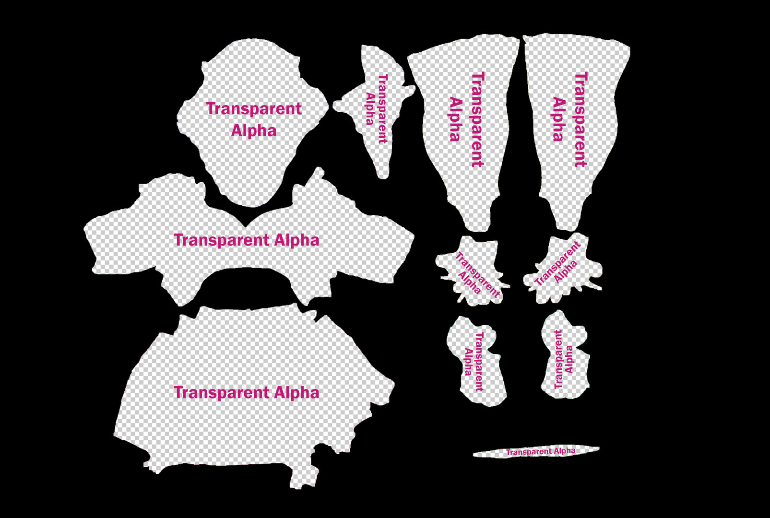

The masked file is used as transparent layer as top layer, in the video editing project. It acts as a mask for positioning your video content to the different parts of your 3D model. When you are finished positioning the map and editing your video texture, export the video file. For best results use uncompressed AVI or MOV formats. These Video Formats create large files but play at optimal performance, since there is little to no decoding required.

**Step 3:** editing the video

In After Effects, we now need to edit our video to fit & rely on, the transparent texture we exported from Photoshop

This is done by importing the PNG/TIEF file & after that, adding the videos below it, in this we will have perfect correlation between the video and the UV texture map.

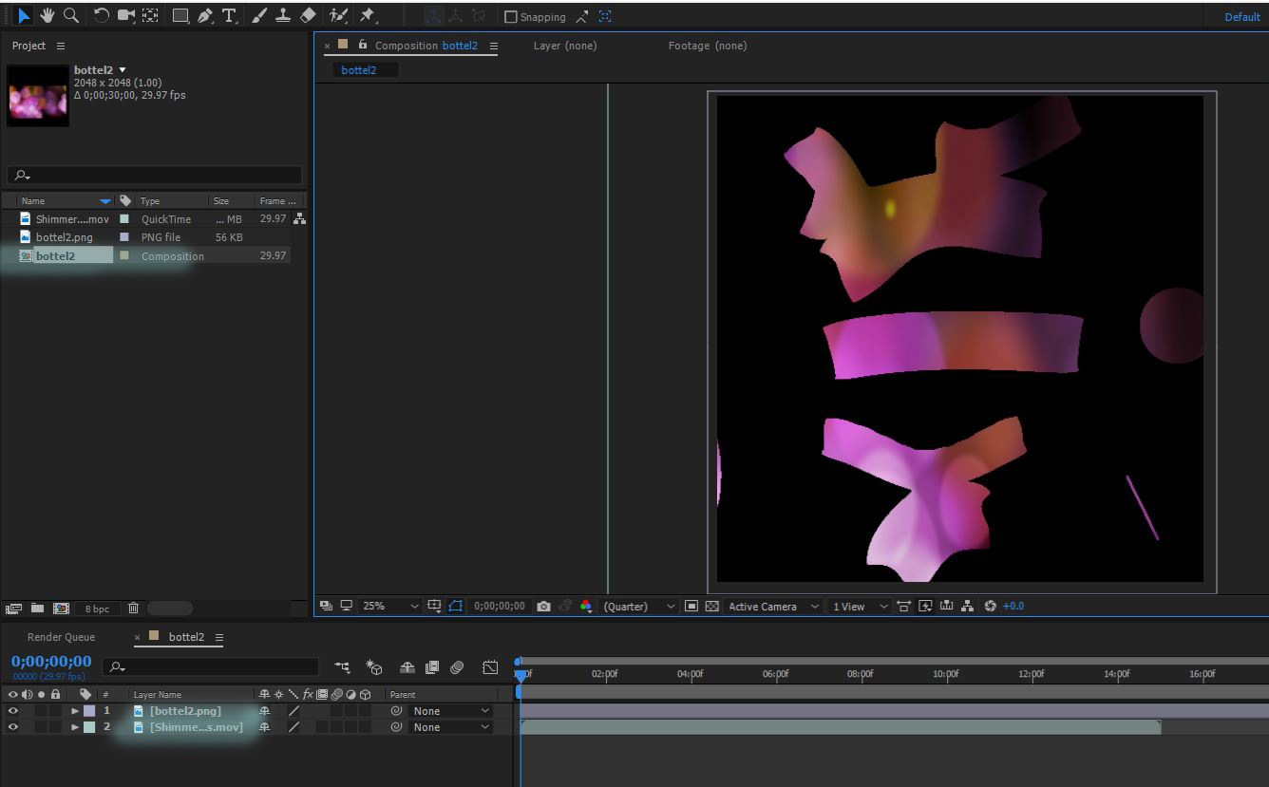

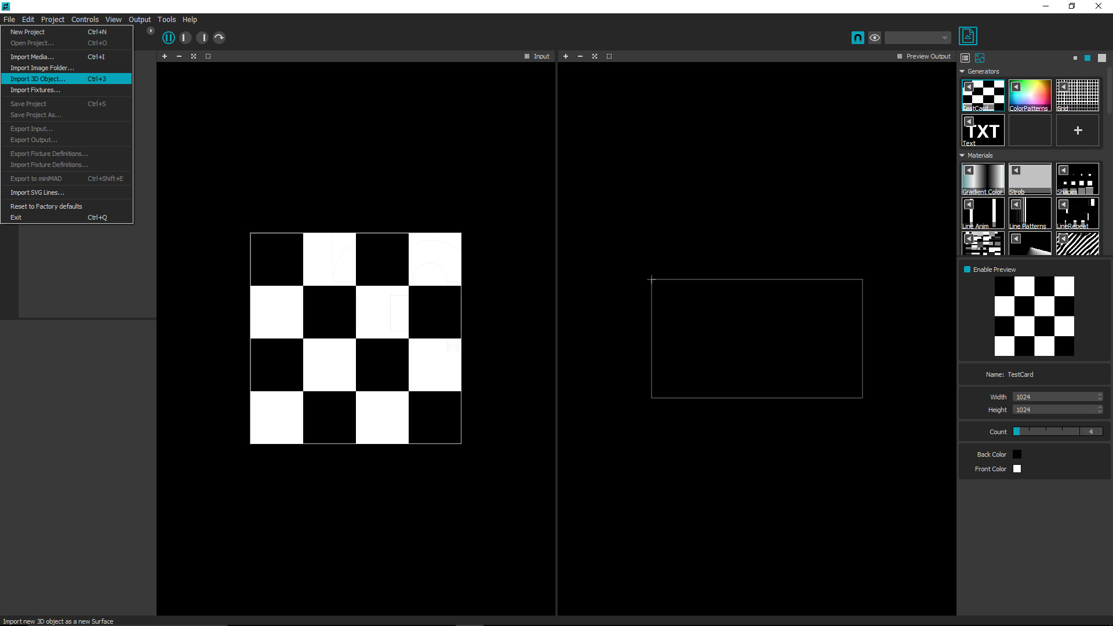**Step 4:** Importing 3D models & video texture into ***Madmapper***

* First launch Madmapper software.
* Click on the **file** dropdown in the top left side of the screen.
* Click on **Import 3D Object**.
* Select your OBJ file. (The same low polygon version we used for UV map)
* Click **open**.

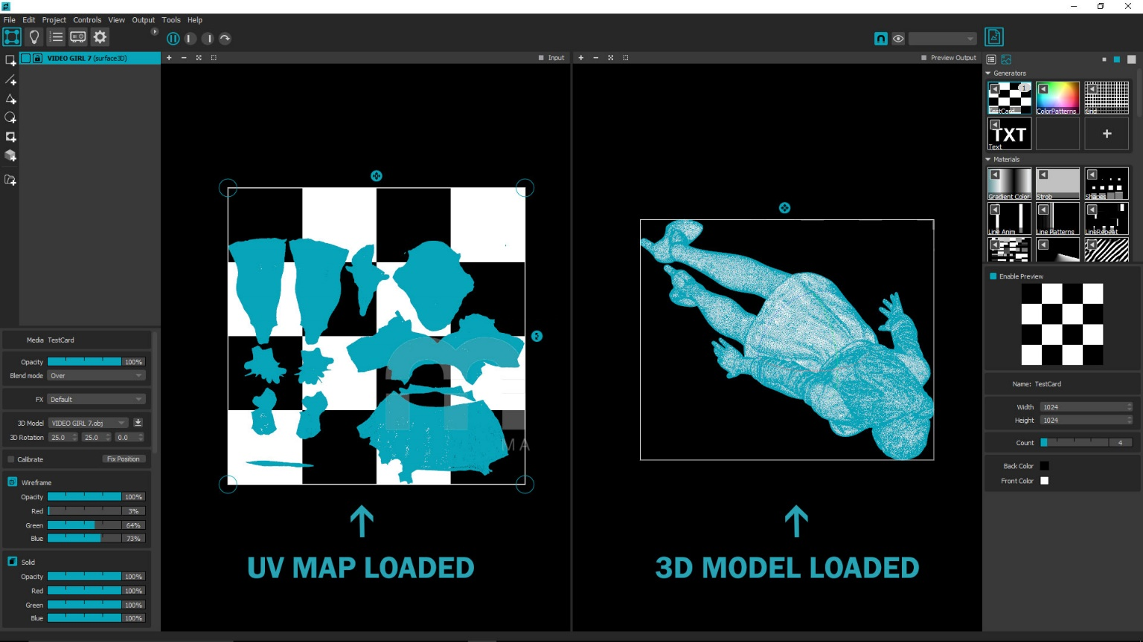 The initial screen right after importing the Obj file, should look like this:

* Click the **file** dropdown again but this time click > **import media**
* Select the UV Video texture from its location on your device.
* Click **open**.
* Scroll to the movies list on the menu on the right-side.
* Right click you’re the icon of the movie you have imported.
* Click **apply** media to selected surfaces.
* Your video file should line up with the UV map.

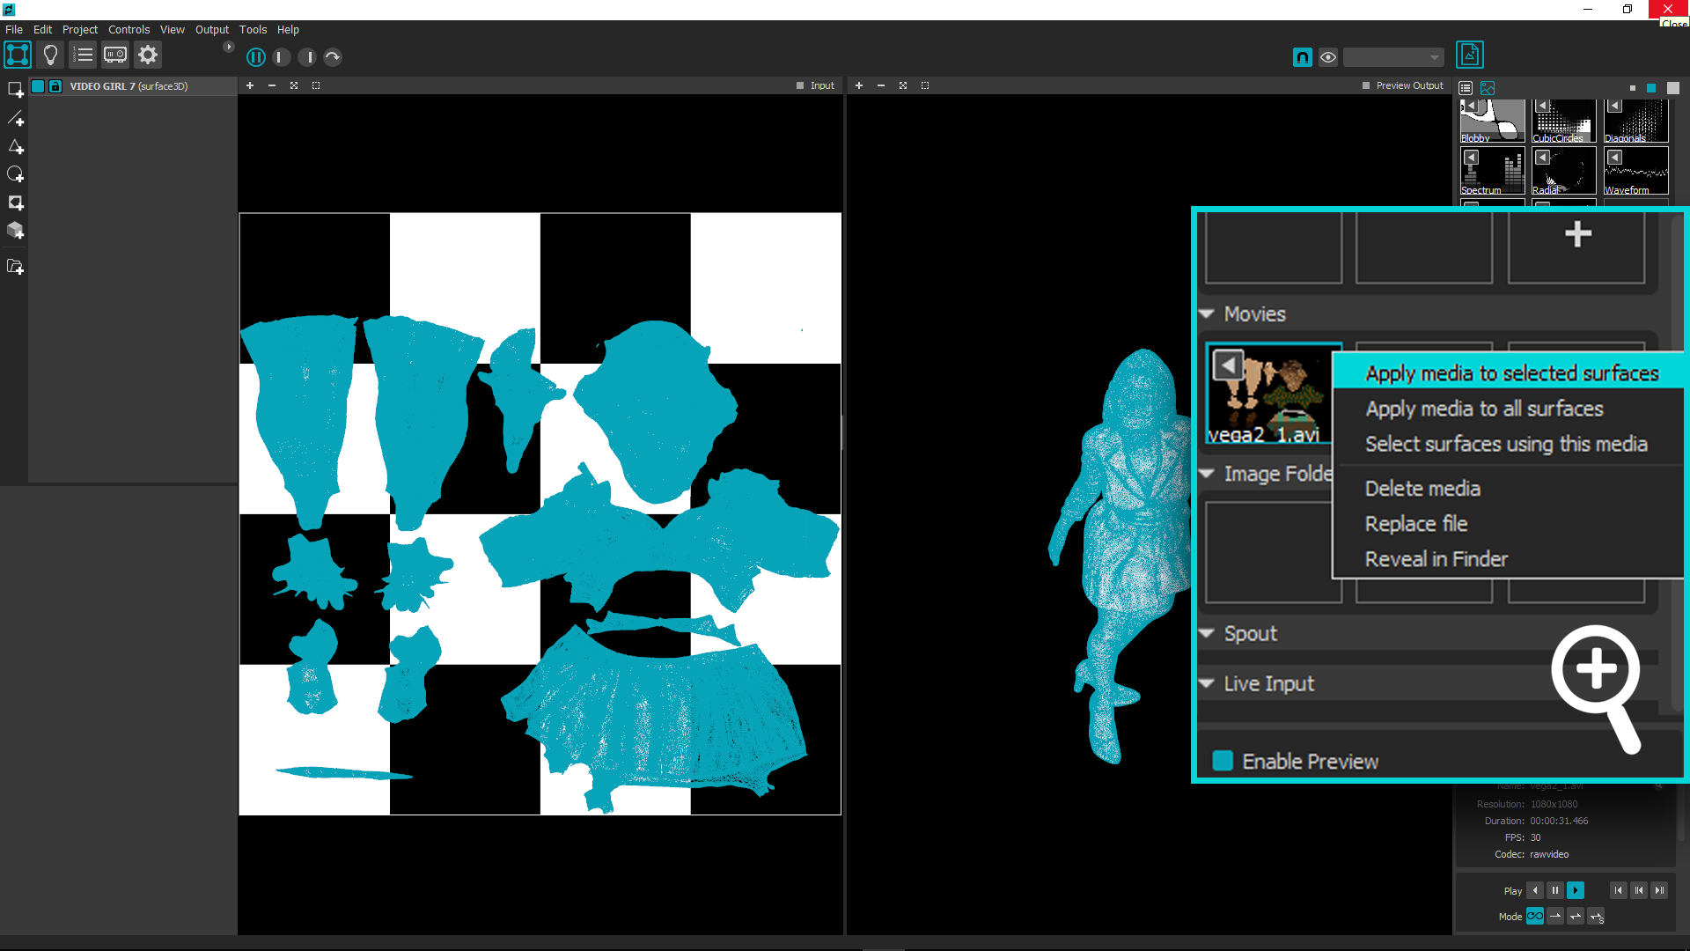

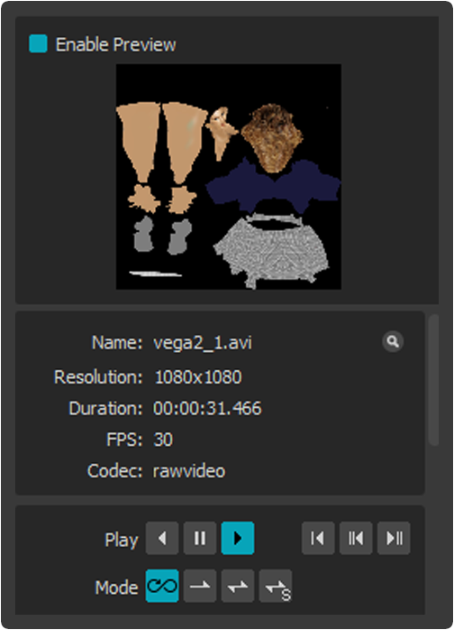

In the media controller, you can play the video forward, backwards, pause and toggle the loop settings.

**Step 5:** Creating a projection

Click the output dropdown and enter **Full Screen Mode.**

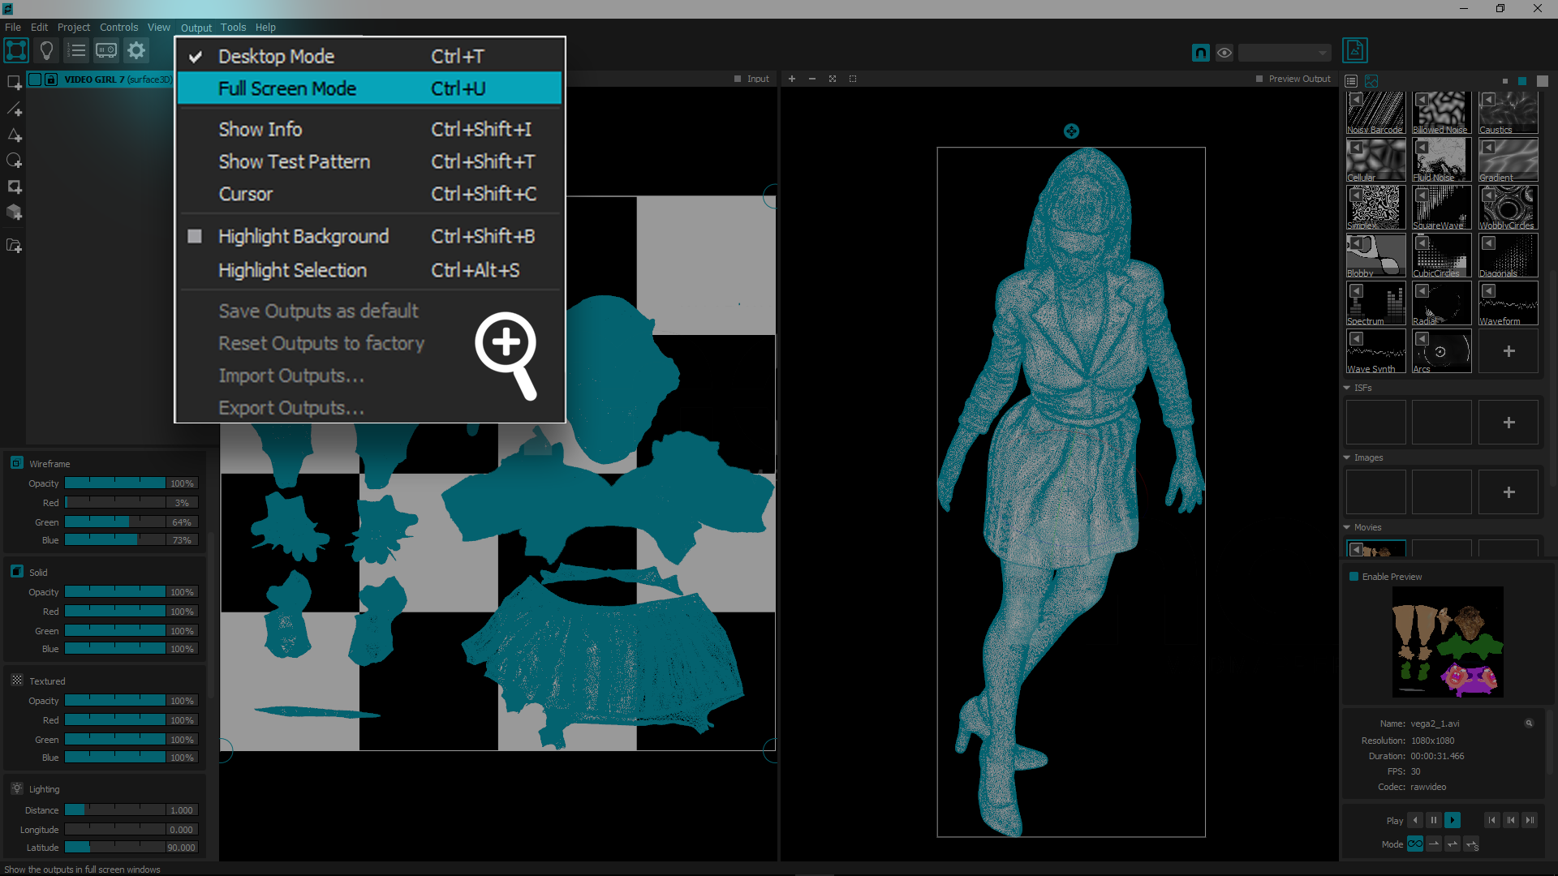**Note:** At this point the projector should display your 3d model in the same way as shown on the right side of the screen.

**Step 6:** Setting up the projection, prior to calibration

Adjust the model’s projection scale and orientation to roughly match the 3D object you want to map. Place the model’s projection next to the 3D object as seen in the diagram below. Do not attempt to place the projection on the 3D object at this stage.

* Left clicking and dragging the gizmos you can scale and rotate the projection.
* Left clicking inside the white outline, you can move the projected models position in any direction.
* Middle clicking and dragging will move the position of the view only without changing the projected models position.

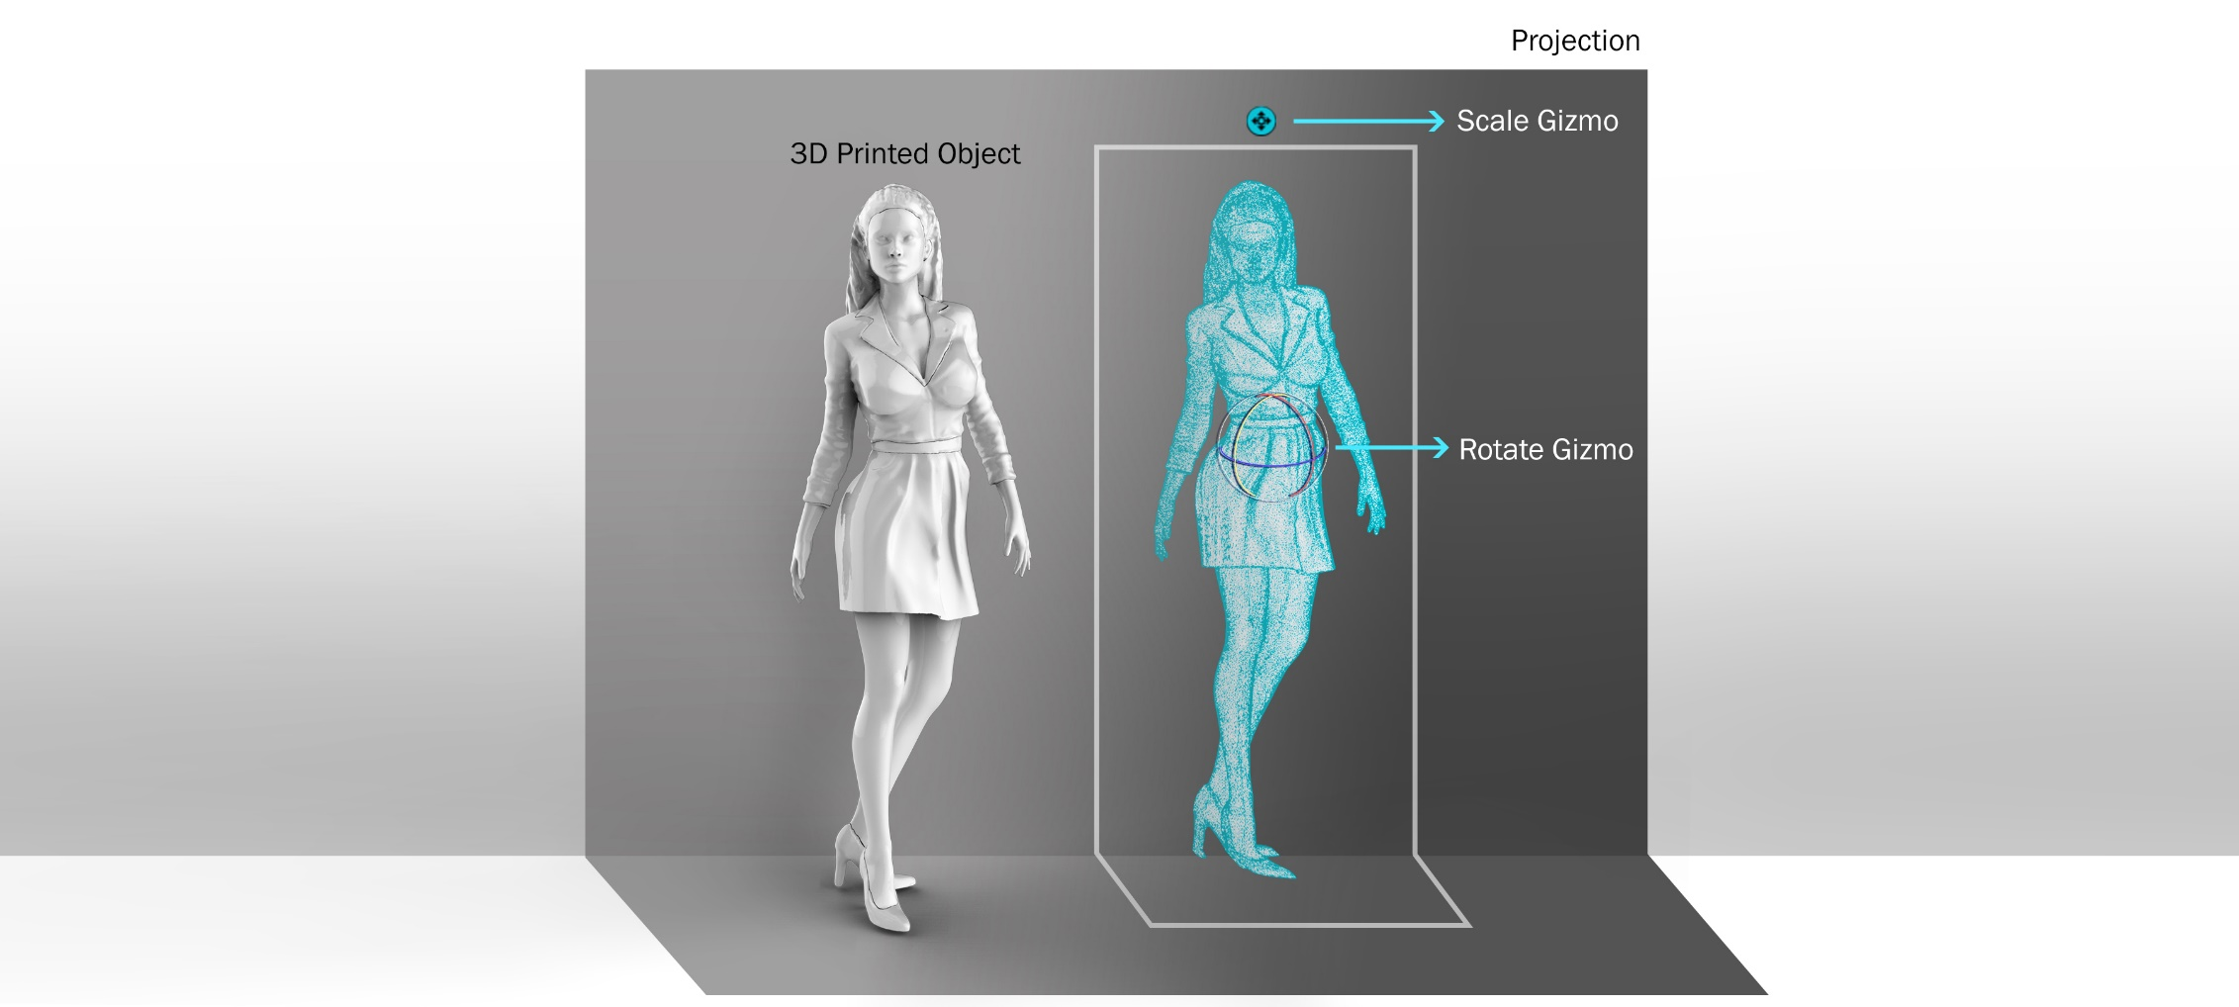

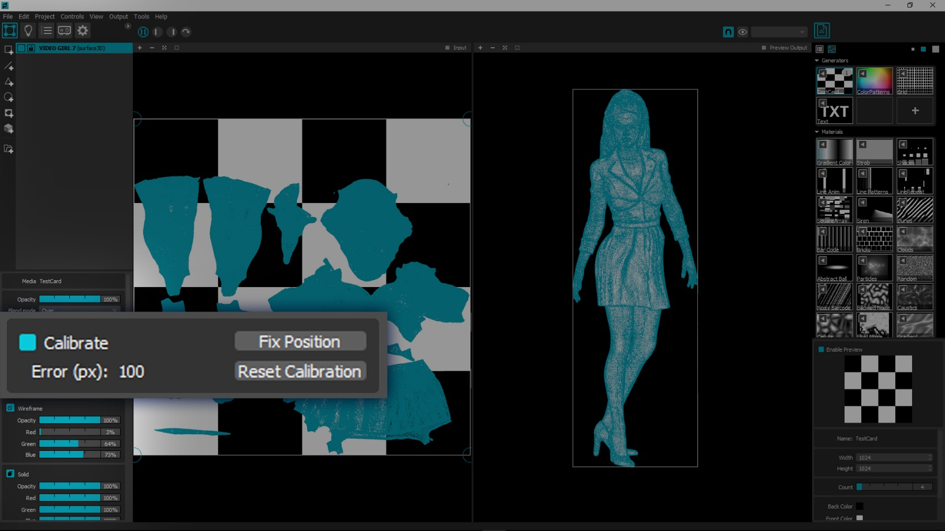**Step 7:**  Projection Mapping Calibration

* Left click to turn on calibrate button in the menu on the bottom left side of the screen to initiate the calibration process.

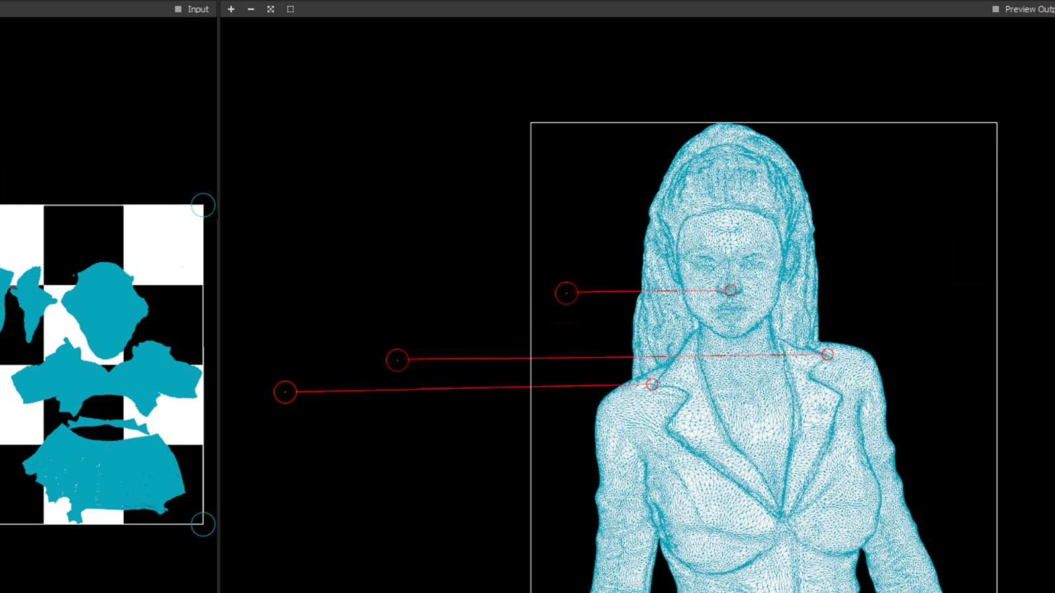

In this stage, you will match the points of the projection and the printed object. This will help Madmapper triangulate and un-distort the projection picture to best match the physical object. At the end of this process Madmapper will wrap the video texture onto the 3D object. For best results spread out the points you pick as much as possible. Try to think in measures such as top left, top right, bottom left, bottom right, & so forth. **(In some models such as the one in the diagram above thinking like this might get tricky.)**

**Quick Tip:** It is good practice to zoom into point using the middle mouse scrolling button selecting a point by pressing and holding the left mouse button and then zooming back out with the middle scrolling button while the left button is simultaneously pressed. Using this practice, you can achieve near perfect accuracy while still having enough space on the screen to move the points to their position.

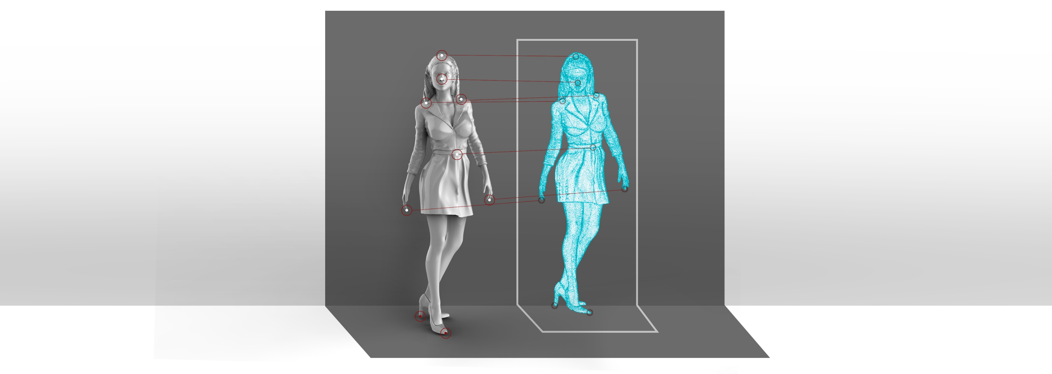

* While hovering over the 3d model the cursor will change into a circle and snap along the mesh of the object.
* Left click a point on the model and drag to a correlating point on the 3D Printed object.
* Accuracy is key in this stage, match the white dot in the center as accurately as possible. Pick the points on the model you can easily recognize on the object. Working this way will help you minimize the margin of error.
* Points can be edited, repositioned or deleted after placement by simply dragging the points to a different position or by clicking them and deleting them using backspace on the keyboard.
* After placing & matching 6 points Madmapper, will auto-wrap the printed object. If for some reason this procedure does not occur check the point’s accuracy in correlation to the objects points.
* Most projections will need more than 6 points to accurately wrap an object. You can continue matching different points after the initial auto-wrapping process to fine tune your projection mapping.
* When you are satisfied with the results click on “**Fix Position**” button in the calibrate menu. You can always edit your calibration by clicking **edit calibration**.
* Save your project in the top menu clicking File> **Save Project as**.

**Step 8:** Applying the video texture & adding effects

* Turn the video texture on by clicking the “**Textured**” button on the menu on the bottom left side of the screen.
* On the bottom left menu, there are a few built in effects that can help refine the overall look of your display. Activate the different effects by clicking their buttons and turning them on. Set the parameters to your liking.
* 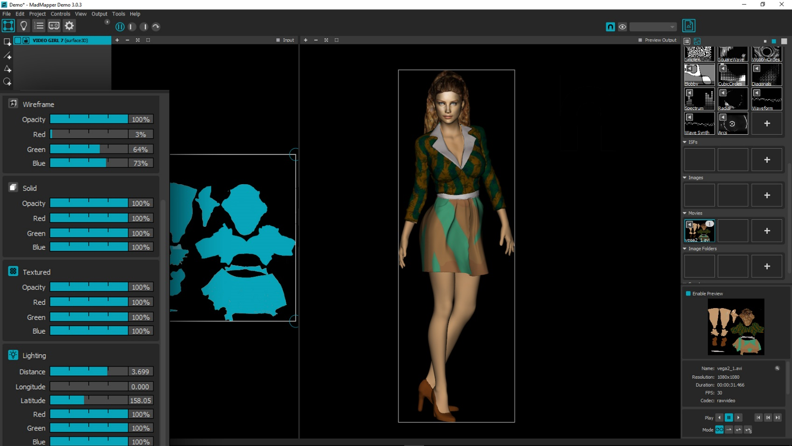It is recommended to work in wireframe mode while setting calibration. This is the reason that solid & wireframe modes are the default when loading a 3D model.
* Adjusting the lighting can help give extra depth or a create dramatic flare to your lighting project

**Good to know:** At the bottom of the menu there is a button “**create lines from visible edges**”. This effect will create a line animation effect from the mesh edges. This effect is meant to be used **only with low polygon models** and tends to cause madmapper to crash when using higher polygon models. It is wise to save your project before attempting to apply this effect.

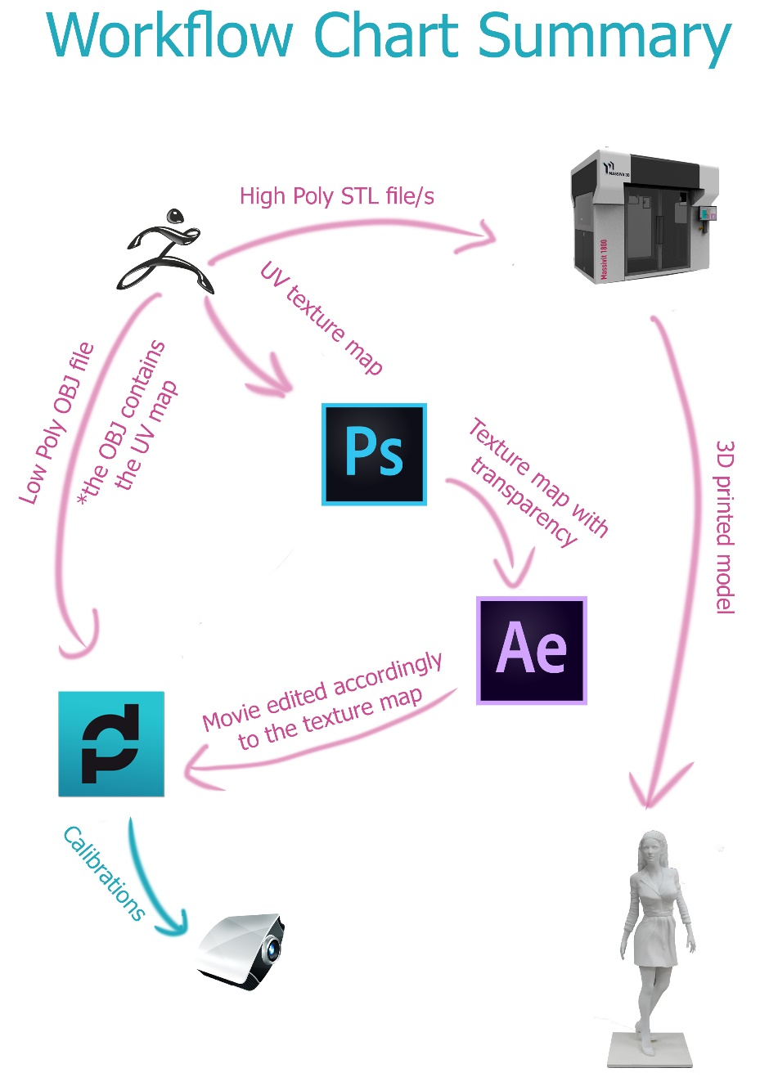

Projection mapping can be a great solution for adding texture, color and motion to your 3d displays. The advantage of printing in 3D for this purpose lies in the fact that UV maps are created from the original 3D file. When the Massivit 3D print is done, the projection mapping process is ready to go in a matter of a few simple steps.

The combination of Massivit 3D printers and Madmapper software offers a simple solution for creating complex eye popping displays with endless possibilities.